Some Notes

**Pastiche:** the output image (original/live feed + stylization)

**Style Image:** the artwork whose style we want

**Content Image:** the original image we want to transfer the style onto

**style loss:** how close the pastiche is to the style image in its style

**content loss:** how close the pastiche is to the content image in its content

The pastiche is initialized to be random noise.

This is then passed through several layers of a network that is pre trained on image classification.

Various outputs of these layers are used to compute the style loss and content loss

Losses are minimized by directly changing (by being subtracted from?) the pastiche after a couple iterations it is a stylzed image

**Losses:**

•get first download link it has the pretrained model

•run it on basic images, like half clear and half red, one with a circle in the middle

•run it for 60 iterations as a baseline, try to point out differences amongst the different types of style images AND content images. Here are some content images I want to use, they are screenshots of some photos I’ve taken abroad (as well as some random ones), I tried to keep them smaller so that the model wouldn’t take forever to run. I might have to adjust the brightness/contrast in them so that the contours are more relevant. I could make a script that adjusts the images until the contours are the most defined.

**Style transfer gif, make split the gif up into three sections and run the program over each section (hopefully each section will only have 5 or so frames)**

**WORKS CITED!!!**

<https://www.youtube.com/watch?v=LoePx3QC5Js> **video tutorial of transfer model**

<https://github.com/Hvass-Labs/TensorFlow-Tutorials/blob/master/15_Style_Transfer.ipynb> **transfer model**

[**https://stackoverflow.com/questions/24731035/python-pil-0-5-opacity-transparency-alpha**](https://stackoverflow.com/questions/24731035/python-pil-0-5-opacity-transparency-alpha) **for the opacity**

[**https://stackoverflow.com/questions/753190/programmatically-generate-video-or-animated-gif-in-python**](https://stackoverflow.com/questions/753190/programmatically-generate-video-or-animated-gif-in-python) **for the gif**

[**https://stackoverflow.com/questions/43284049/spectrogram-of-a-wave-file**](https://stackoverflow.com/questions/43284049/spectrogram-of-a-wave-file) **spectrogram**

[**https://stackoverflow.com/questions/33311153/python-extracting-and-saving-video-frames**](https://stackoverflow.com/questions/33311153/python-extracting-and-saving-video-frames) **making video**

**Progress…**

**Tried to reopen it and it didn’t want to work at first. I then played around with the images and realized that the style image has to be larger than the content image in order for it to work**

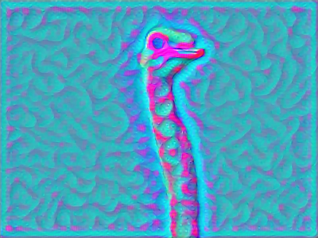

**ostrich: 400 x 300 squiggles: 756x709**

**Because this runs by comparing images, in order to make a moving gif line up with these i took a video and split it up into images, the first third get the first style image, second get the second and so on**

**Low target - get it to work with your own images and create a gif. Still content image, 3 style images**

**Medium target - add your separate methods into the main code body,**